**AI in Agriculture: A Case Study Analysis**

**Introduction**

There is an increasing push for AI in the agricultural industry. The recent push was accelerated by COVID-19, which saw a shortage in the workforce. AI was pushed to make up for this, and agriculture has seen a dramatic increase in AI-driven technology. The rise of AI in agriculture holds profound implications for society, extending far beyond the farm itself. One major impact is the potential to enhance food security on a global scale. By optimizing crop production, reducing waste, and improving resource management, AI can contribute to increased yields and a more stable food supply, particularly in regions vulnerable to food shortages. This has the potential to alleviate hunger and poverty, leading to improved health and well-being for millions worldwide. Moreover, AI-powered agriculture can promote sustainability by minimizing the environmental footprint of farming practices. This can lead to reduced pesticide and fertilizer use, less water consumption, and healthier ecosystems. Important components in agriculture, including crop productivity with more accurate data insight and even cutting costs on laborless tech. Introducing data analysis with historical data can also be key to increased performance for agriculture businesses. AI in agriculture is forecasted to grow from $1.52 billion in 2023 to $10.9 billion in 2032. (FactView Research, 2023)

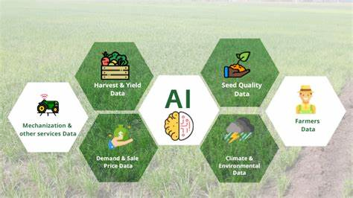

**AI Application Analysis**

The AI implementation can come through multiple methods. One popular method is unmanned aerial vehicles (UAVs), also known as drones, which are used for data analysis through data collection, precision farming, and real-time monitoring without the need for physical employee work.

Cameras and sensors installed on the drones can capture crop data, any ongoing field information, and pest levels, among other things. Rain and soil information captured can be inputs to predictive data analysis, and give a number to how well a crop is performing. Real-time weather analysis can be utilized by leveraging AI cloud services to perform GPU-heavy modeling. The use of computer vision, predictive analysis, and machine learning via sensors and cameras is becoming more needed as technology advances. (FactView Research, 2023)

*Benefits*

Artificial intelligence in agriculture is largely targeting farming practices to improve efficiency, sustainability and yield. AI systems give farmers valuable data-led insights into all aspects of ag operations. AI benefits farmers by helping analyze information on crop health, soil conditions, and potential pest threats. In doing so, farmers make more informed decisions regarding key timing with planting, fertilization, and pest control.

Ultimately, this gives growers increased productivity and higher yields. The precision farming approach helps farmers determine the best use of operations budgets by optimizing resource allocations for water, fertilizers, pesticides and more.This reduces waste, lowers initial in-ground costs and makes farm operations more efficient.

AI also allows farmers access to powerful remote monitoring and predictive analytics tools. Farmers can be freed up to be off their ground while still managing real-time updates on crop conditions and being able to make time-sensitive decisions. Proactive and strategic decisions help safeguard crops and again maximize productivity.

Finally, AI is used in agriculture to review historical data and predict future trends, be it weather forecasting, crop performance, machinery choices or goods-to-market trends. Farmers are better equipped with AI to operate their farms efficiently and in a data-driven way.

*Challenges*

Though there are countless benefits and future opportunities for AI in agriculture, it is also necessary to acknowledge the challenges that come with integrating such technological advancements. A core issue in the pursuit of a data-driven AI system for agriculture is the lack of standardization in data collection across the industry. AI requires not only large, but consistent datasets to aggregate and analyze data effectively. Inconsistencies in data formatting and accuracy will return misleading model results.

The widespread adoption of AI in ag will only work as farmers can scale with technological expertise for the maintenance and operation of these advanced systems. A shortage of AI skilled workers in this industry could slow the pace of integration and stunt its full potential.

**Ethical and Social Implications**

*Ethical Considerations*

While there are specific challenges to consider when adopting artificial intelligence for agriculture, the ethical concerns for AI implementations are similar across all boundaries.

First and foremost is the protection of data privacy for farmers. Like any other industry, the protection of data is key, be it trade secrets, crop studies, or banking decisions. Working to eradicate AI bias and fairness is necessary to ensure that all farmers have some level of access to make good decisions with their operation. In addition, there are some concerns about computational demands, and related power needs, for the large language models or AI-driven surveillance systems. This may make energy usage less effective and efficient if not monitored closely.

*Societal Impact*

The fast adoption of AI in agriculture will cause profound implications for society. One major impact is the potential to enhance food security on a global scale. AI can contribute to increased yields and a more stable food supply, particularly in regions vulnerable to food shortages. This has the potential to alleviate hunger and poverty, leading to improved health and well-being for millions worldwide.

**Future Directions**

Recent research demonstrates the effectiveness of machine learning and deep learning in accurately identifying and classifying crop diseases. The paper by Tirkey et al. specifically proposes a deep-learning approach to detect insects in soybean crops, enabling early intervention and reducing losses.

Another emerging trend is the increased adoption of drones in agriculture. Drones equipped with AI technology collect high-resolution aerial data, analyzing fields for crop health, irrigation needs, and pest infestations. This leads to optimized resource location, reduced costs, and increased crop yields. (FactViewResearch)

The third significant development is the rise of agricultural robots, with expectations that automated farming will become commonplace by 2025. Researchers are discussing how robots offer increased efficiency, accuracy, and reduced labor costs. Robots are being utilized for tasks like harvesting, where they use sensors and cameras to determine the optimal time for picking fruits and vegetables. They employ robotic arms with specialized grippers to carefully harvest produce, reducing damage and increasing efficiency. “Another trend is the development of robotic systems that can perform multiple tasks, such as planting, fertilizing, and spraying, all in one pass. These multi-tasking robots offer increased efficiency and reduce the need for multiple pieces of equipment and human labor” (Catherine Bernier).

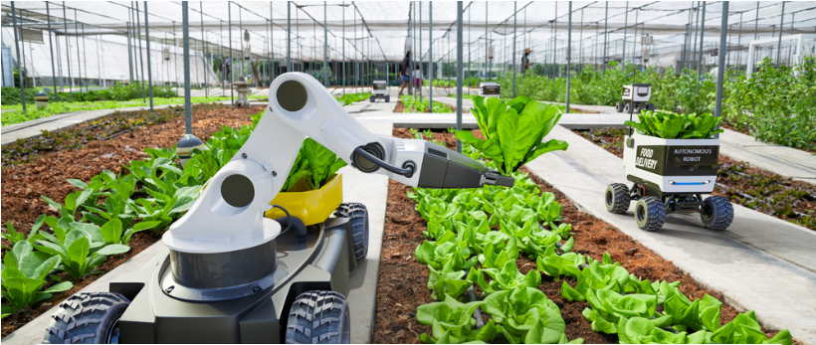

Certain challenges need to be addressed to fully harness the potential of AI in agriculture, such as making AI more accessible to small-scale farmers. In his Medium article, Canda suggests lowering AI costs through financial support or affordable alternatives, providing education and training programs for farmers, encouraging anonymous data sharing to enhance insights, and establishing clear data privacy regulations (2024).

**Conclusion**

AI is transforming the agricultural industry by enhancing efficiency, productivity, and sustainability. The increasing adoption of AI-driven technologies, such as drones equipped with cameras and sensors, enables precise data collection and real-time monitoring of crop health, soil conditions, and pest levels. This technology empowers farmers to make informed decisions on planting, fertilization, and pest control, leading to higher yields and reduced waste. The promising agricultural robots will further streamline farming operations by performing multiple tasks like harvesting, planting, and fertilizing with greater accuracy and reduced labor costs. However, to fully harness AI's potential, challenges such as accessibility for small-scale farmers need to be addressed. Lowering costs through financial support, providing education and training, encouraging data sharing, and establishing clear data privacy regulations remain essential toward inclusive and sustainable AI integration in agriculture.

**References**

Bernier, Catherine. "Harvesting Robots: Automated Farming in 2025." How to Robot, 14 Dec. 2023, <https://howtorobot.com/expert-insight/harvesting-robots>.

Canda, Jam. "AI in Agriculture: Crop Monitoring and Precision Farming." Medium, 6 Apr. 2024, <https://medium.com/@jam.canda/ai-in-agriculture-crop-monitoring-and-precision-farming-016f79c11938>.

FactView Research. "Global Artificial Intelligence in Agriculture Market Size, Industry Growth & Sector Analysis By 2030." FactView Research, Nov. 2023, <https://factviewresearch.com/report/global-artificial-intelligence-in-agriculture-market>.

Texas A&M AgriLife. "AI in Agriculture Abstracts." 2024, <https://agriliferegister.tamu.edu/website/63088/#agenda>.

Tirkey, Divyanshu, Kshitiz Kumar Singh, and Shrivishal Tripathi. "Performance Analysis of AI-Based Solutions for Crop Disease Identification, Detection, and Classification." Smart Agricultural Technology, vol. 5, 2023, p. 100238. ScienceDirect, <https://doi.org/10.1016/j.atech.2023.100238>.